Fidel Castro
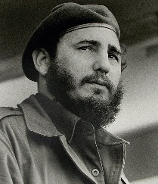

Born August 13, 1926 in Biran, Cuba, Fidel Castro was the son of a wealthy land owner and a maid. He was well educated and led the overthrow of the 1959 Batista dictatorship in Cuba.
Fidel revolted against Fulgencio Batista throughout the 1950s due to the oppression and brutality of the dictatorship. During Batista’s first presidency he was a good and fair leader; however when he returned in 1952, he returned as a vicious dictator. He controlled the press and suppressed any and all opposition with extreme violence. He stole millions of dollars from the country and ruled with absolute power.
When Fidel began to speak out against the regime, Batista accused him of being a communist. He warned the people that Fidel was not all he claimed to be. However, in 1959 he fled Cuba and Fidel Castro was named the new leader of Cuba.
Fidel promised to make the country a democracy and free the people. Unfortunately he was dishonest, and one year after being named Prime Minister, he began cozying up to the very communist Russia.
In the early 1960s, Fidel made Cuba the first communist country in the Western Hemisphere, which clearly showed his ideology/philosophy to be communist. Although he originally promised to make positive changes for Cuba, he became controlling and oppressive. He led Cuba dangerously close to nuclear war with the United States during the cold war and has continued to control and oppress the people for over fifty years.

