Che Guevara
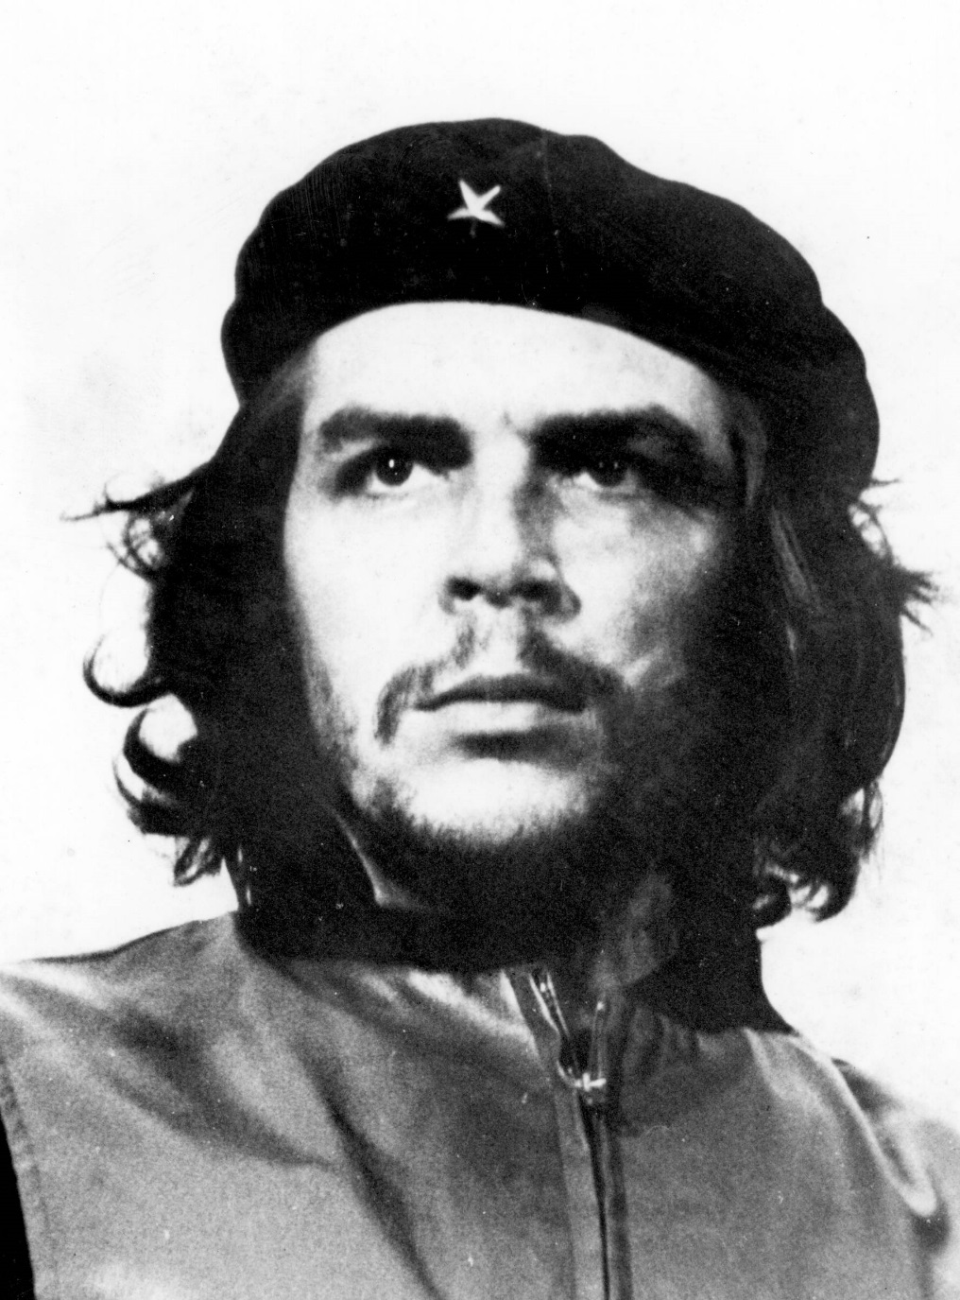
Che Guevara was born June 14, 1928 in Rosario, Argentina. He was born to a privileged family, and due to a childhood illness decided to study medicine. While attending school he left Argentina and traveled through South America. During these travels his aspiration to become a doctor was affirmed by the poverty and illness he saw. He returned to his home and finished school.
His travels had cemented his leftist Marxist/Socialist beliefs. After witnessing a revolution in Guatemala, Che decided to fight to bring socialism to the world. Socialism is when society is organized so that major industries (farming, healthcare, etc) are owned by the government so that all the people can benefit equally. In 1956 he met and became friends with Fidel Castro and his brother Raul Castro. The Castro brothers convinced Che that the only hope for the impoverished and oppressed people of South America was revolution. That same year he joined the brothers in an invasion of Cuba. Although wounded he continued to fight alongside Fidel and was a prominent thinker and leader in guerilla warfare.
The revolutionaries led by Fidel and Che were able to successfully overthrow the Cuban dictator Batista. Once the dictator Batista was deposed, Fidel was named Prime Minister and created a communist government, which was based on socialist ideas. Che rose to power with him, and Fidel and Che remained close friends and confidants. Che was named the president of the National Bank of Cuba and the chief of the Industrial Department of the National Institute of Agrarian Reform.
After the Cuban revolution, Che wrote several letters and essays on his support of socialism, and he wrote several against the United States and colonialism.
He took part in revolutions in the Republic of the Congo and in Bolivia. While supporting guerrilla warfare activities in Bolivia, he was captured and killed in October of 1967. Che Guevara has become an international symbol for revolution and rebellion.

