Leon Trotsky
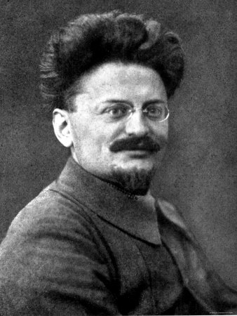
Leon Trotsky was born Lev Davidovich Bronshtein on November 7, 1879 in Ukraine, which was a part of the Russian Empire. He became acquainted with Marxism and socialism philosophies in 1896 and became a part of the socialist movement. He helped to organize the underground South Russian Workers’ Union. Like many Russians, he was opposed to the Tsarist (Monarchist) government due to the stark differences between the quality of life for the nobility and that of the common people.
Trotsky was arrested and exiled for his revolutionary activity in January of 1898. He escaped and fled to London in 1902. While there, he met Vladimir Ulyanov (Lenin). By this time he was a devout Marxist and socialist. He continued to be involved in the revolutionary activities in Russia and was arrested and exiled a second time; again he escaped.
Trotsky traveled Europe and reached New York in 1917 where he worked on a Russian language newspaper. He returned to Russia in mid-May and became the leader of the foreward-thinking, left-wing faction. Once Lenin was placed in power of the country, Trotsky received the position of foreign commissar. He continued to further the socialist movement and was clearly second in charge for the duration of Lenin’s rule.
When Lenin became ill and needed to name a successor, he chose Trotsky. Unfortunately for Trotsky he didn’t act quickly and lost the support of the party. Stalin gained control and shortly thereafter exiled Trotsky. He moved from Europe and settled in Mexico. In 1940 he was assassinated by a Mexican Communist.

