Analyzing Layout
Name: _____________________________________________________ Date______________________Pd ___________
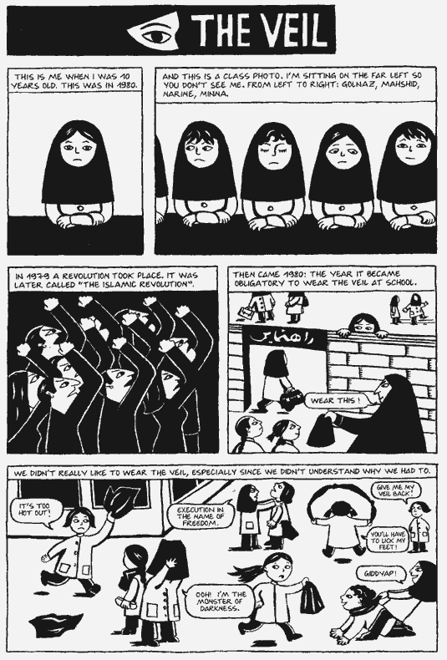
- How many panels are shown on the page?

- What is significant about the color of the third panel?

- What is one figure of importance in the fourth panel?

4. Why does Marjane Satrapi include foreground, middle ground, and background?

5. Why is Marjane alone in the first panel?

On your own analyze the following pages layout and answer the questions that follow.
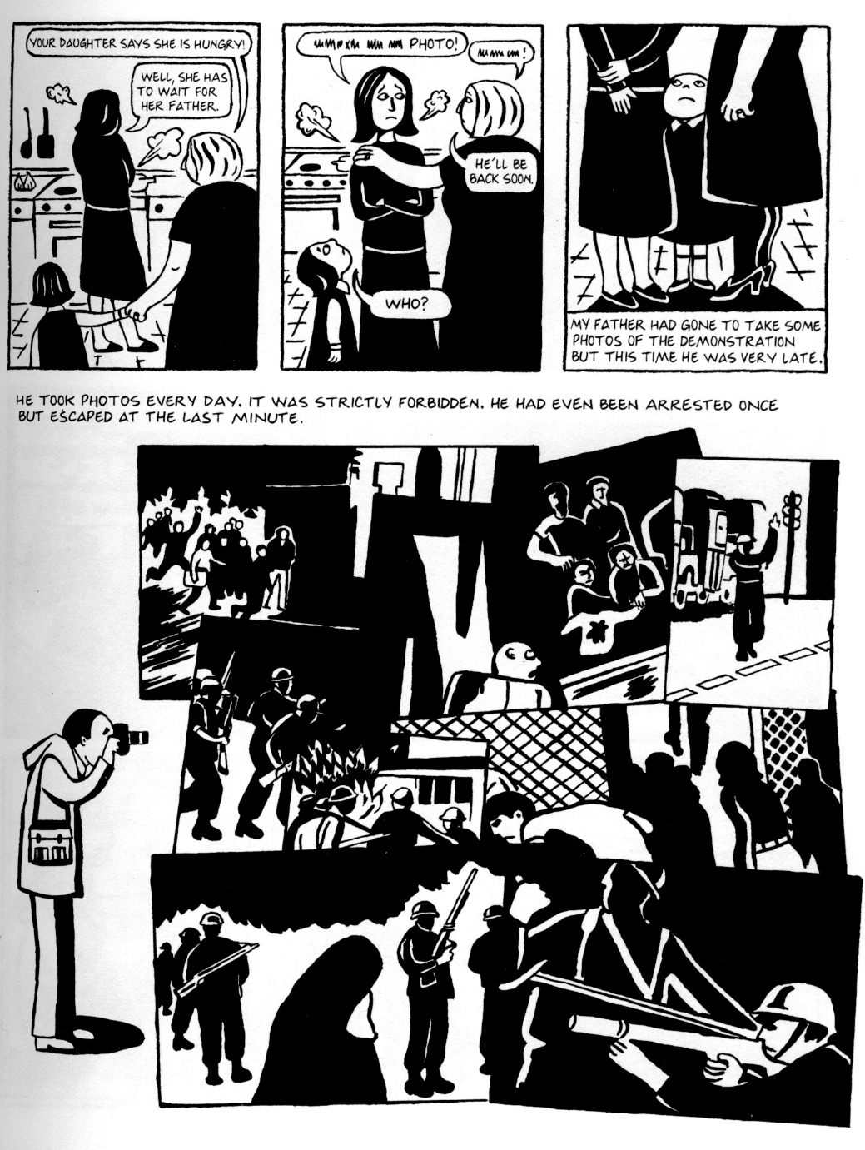
- Why is the father next to the group of photos and not in one of the panels?

- Why does Marjane include so many of her father’s illegal photos on the bottom of the page?
- What is shown by the photographs taken by Marjane’s father?

- Why is there a caption in the third panel and not in the first two?

