Nik Wallenda nears the completion of his 1,400 foot walk across the Grand Canyon.
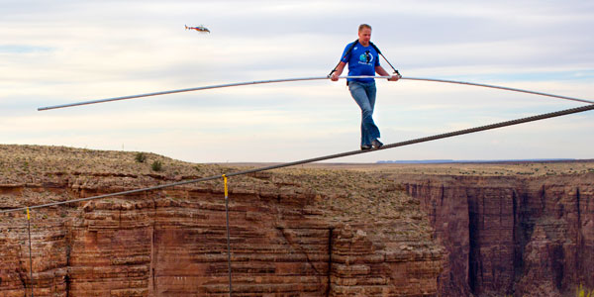
Man walks wire across Grand Canyon
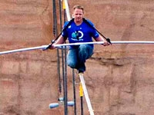
Nik Wallenda studied the plunging walls of the Little Colorado River Gorge before stepping out on a quarter-mile tightrope cable. "Whoo! That's an amazing view."
With that observation, the well-known aerialist embarked Sunday afternoon on a walk without a safety net or harness, 1,500 feet above the Little Colorado River Gorge in northeastern Arizona.
The successful, 22-minute walk on the 2-inch-thick steel cable was monitored by people around the world via television and computer screens during a broadcast of Wallenda's most ambitious stunt yet.
They watched as the winds tested the Florida daredevil, and listened as he called on God to calm the swaying cable and as he paid homage to his famed great-grandfather. The stunt was the leading trending topic on Twitter on Sunday afternoon.
"It was unbelievable," he told reporters later. "It was everything I wanted it to be. It was extremely emotional. I got to the other end and started crying."
During his walk above the dry river bed near the Grand Canyon, Wallenda paused and crouched twice as winds whipped around him and the rope swayed. Gusts had been expected to be around 30 mph. He said they sent dust flying into his eyes.
"It was strenuous the whole way across. It was a battle. The winds were strong, they were gusty," he told reporters. "But there was never a point where I thought, 'oh my gosh, I'm going to fall.'"
Wallenda stepped slowly and steady throughout, murmuring prayers to Jesus almost constantly along the way. He jogged and hopped the last few steps.
"Thank you Lord. Thank you for calming that cable, God," he said about 13 minutes into the walk.
Nik Wallenda grew up performing with his family and dreamed of crossing the Grand Canyon since he was a teenager. Sunday's stunt comes a year after he traversed Niagara Falls earning a seventh Guinness world record.
Wallenda already is eyeing his next stunt, which he hopes will take him between the Chrysler and Empire State buildings in New York. As a nod to his Internet audience, he said he also would ask his Facebook and Twitter followers what the next challenge should be.
But he said he would give up tightrope walking altogether if his wife and children ever asked him.
"That's a serious talk that we'll have. But absolutely, it weighs on heavy on me," he said.
- Posted on June 26, 2013

