History of Iran
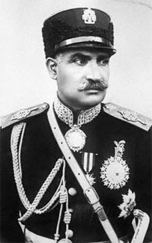
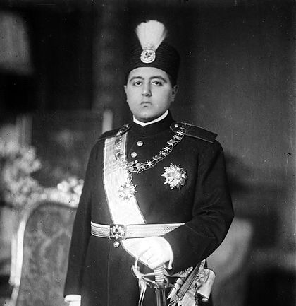
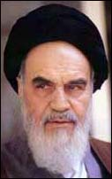
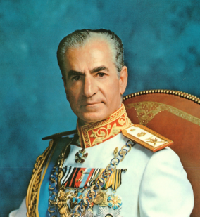

Leader’s Info | Leader’s Info | Leader’s Info | Leader’s Info

Compare Contrast
Shah Reza Pahlavi | Ayatollah Khomeini
Similarities

