Mission Impossible: Revolution Relay
Names:

Your mission if you choose to accept is to gather as much information on four historical revolutionaries. Your team will collect the information from the posters strategically hidden in the hall. One team member at a time will go to the hall and in absolute silence steal the information from the info portals. You must quickly race back to your team and relay the information to them. You are allowed to return to the portal as many times as necessary to gather the appropriate information. The team with the most accurate information will succeed and be named the victor. As victors your team will be entitled to ten bonus points on your next assessment. Complete the diagram on the back before beginning the Intersection and Reflection Questions.
Reflection Questions
1. Is violent overthrow of the government ever acceptable? If so please explain.

2. What is the best way for citizens to make a change?

3. What revolutionary do you find the most interesting and why?

Intersection Questions
- What is similar between the four revolutionaries? (Think big picture ideas)

- Were any of these revolutionaries successful in enacting positive change in their countries?
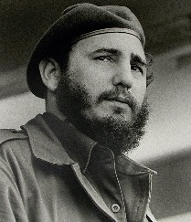  Fidel Castro  - What is the country of action?  - What was the philosophy or ideology of the man?  - What caused him to act against his government?  - What was the result of his action? | 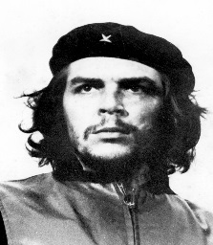  Che Guevara  1. What is the country of action?  2. What was the philosophy or ideology of the man?  3. What caused him to act against his government?  4 .What was the result of his action?
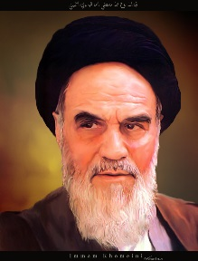  Ayatollah  Khomeini  1. What is the country of action?  2. What was the philosophy or ideology of the man?  3. What caused him to act against his government?  4 .What was the result of his action? | 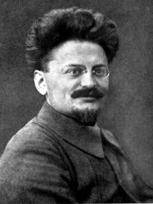  Leon Trotsky  1. What is the country of action?  2. What was the philosophy or ideology of the man?  3. What caused him to act against his government?  4 .What was the result of his action?

