Name: ______________________________________ Date: _________________ Period: ________
Graphic Novel Terms and Concepts

Concept 1: Layout
Layout: Layout refers to how panels are arranged on a page.
- Are there 3 panels in a row? Is one panel larger than the others?
Panel: A panel is an individual frame, or single drawing, in the multiple-panel sequence of a comic strip. A panel consists of a single drawing depicting a frozen moment.

Frames: The lines and borders that contain the panel

Gutter: The space between framed panels

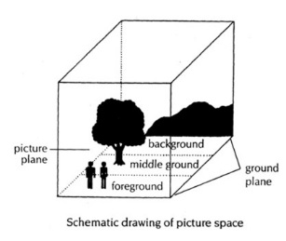
Bleed: An image that extends to and/or beyond the edge of the page
Foreground, Midground, Background show where an object is in space. Is it close up or is it far away?
- Foreground: Objects in the foreground appear to be closest to the viewer. Foreground shows us the main focus of a panel.
- Midground: Midground objects are in between the foreground and background.
- Background: Background shows the images that are farthest away. Background objects provide additional, subtextual information for the reader.
The objects in the midground, and background help provide story support and establish mood.

Graphic weight: A term that describes the way some images draw the eye more than others

Authors can use graphic weight to create a specific focus using color and shading in various ways including:
- The use of light and dark shades: Dark images and high-contrast images draw the eye more than light images.
- A pattern or repeated series of marks.
Concept 2: Figures
Faces: Faces can be portrayed in different ways. Some depict an actual person, like a portrait; others are iconic, which means they are representative of an idea or a group of people.

Other points to observe about faces include:
- They can be dramatic when placed against a detailed backdrop; a bright white face stands out.
- They can be drawn without much expression or detail; this is called an “open blank” and it invites the audience to imagine what the character is feeling without telling them.

Hands/Feet: The positioning of hands and feet can be used to express what is happening in the story.
- Hands that are raised with palms out suggest surprise or fear.
- The wringing of hands suggests obsequiousness or discomfort.
- Hands over the mouth depict fear, shame, or shyness.
- Turned in feet may denote embarrassment.
- Feet with motion strokes can create the sense of panic, urgency, or speed.
Shading and Color: Color and shading show feelings, moods, and emotions with different colors.
- Is an object solid black, light grey, or white? The colors and shading matter.

Concept 3: Text
Captions: These are boxes containing a variety of text elements, including scene-setting, description, etc.

Speech balloons: These enclose dialogue and come from a specific speaker’s mouth.
- They vary in size, shape, and layout.
- They alternate to depict a conversation.
- Types of speech balloons include those holding:
  - External dialogue: speech between characters
  - Internal dialogue: a character’s private thoughts (a thought enclosed by a balloon that has a series of dots or bubbles going up to it)
Special-effects lettering: Special lettering is different from the normal lettering in captions or speech balloons.
- This is a method of drawing attention to text.

Name: ______________________________________ Date: _________________ Period: ________
Analyzing the Elements of a Graphic Novel
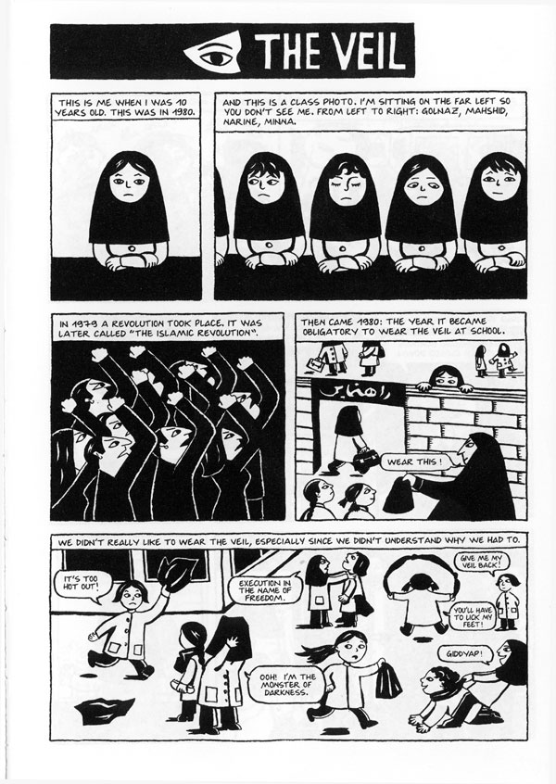
Describe the layout of the page.
- How many panels are there?
- How many fit in a strip?

How do you read the layout of a graphic novel?
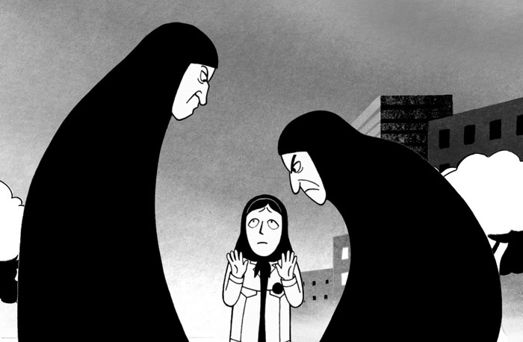
Notice the coloration of the two ladies in the picture. Why has the illustrator chosen to color the women in all black?

What mood does this panel give the reader? How do you know?

What does the positioning of Marjane’s hands tell the reader?
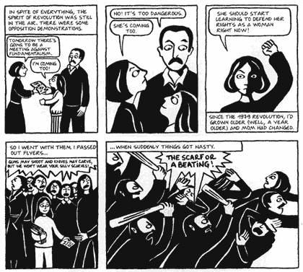
What is the purpose of caption narration (found in the boxes at the top or bottom of a panel) in a graphic novel?

Why are some of the speech balloons jagged?

Do you read a speech balloon differently depending on the shape? How do you know?

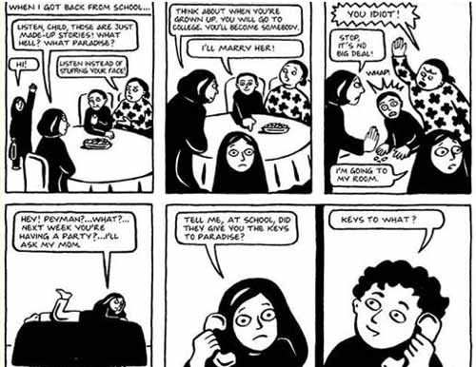

How do you read a page with multiple speech balloons?

Name: ______________________________________ Date: _________________ Period: ________
Analyzing Elements of Comics: You Do!
Directions: Analyze the page below. Consider and describe all of the elements of a comic. Be sure to explain something about each of the following: layout, panels, graphic weight, color/contrast, text (captions and speech bubbles), and figures. Your answers should be written in complete sentences.
Layout:

Panels:

Graphic Weight:

Color & Contrast:

Captions and Speech balloons:

Figures:
Name: ______________________________________ Date: _________________ Period: ________
Reading with Prosody
So, you think you are ready to read a graphic novel, right? WRONG! There is one more piece to the puzzle: reading with prosody. Part of the time, we will be reading Persepolis out loud and in class. Because this graphic novel is SO AMAZING and LIVELY, we have to do it justice by reading with amazingness and liveliness as well. If not, YOU will make this boring and uninteresting. (Tsk tsk tsk! Shame on you!)
Prosody is __________________________________________________________________________________________________________________________________________________________________________________________

If I read with prosody, what is the effect?
__________________________________________________________________________________________________________________________________________________________________________________________

You need to add volume, flow, character, and timing into your reading.
Volume. Flow. Character. Timing.

Volume: This is the power to control your voice and how loud you project what you are saying to your audience. You do not have to YELL, but you need to raise the volume of your voice so everyone can hear.

Flow: This is what is called “fluency.” There are no random pauses. You do not mess up and then give up. You sound clear. You sound like you know what to say. You sound confident. Everything you say just flows.

Character: This is your capability to add creativity and charm to what you are reading. If you want to use character voices, you should! You give every voice, every character, every word its own personality. You do not sound like the same person every time you read. You modify your reading to fit what’s happening in the text.

Timing: This is your capacity to speed up the reading or slow it down, depending on what is being said and read in the text. You can slow down your reading to add suspense, you can hurry your voice to show a tone of urgency, and you can add dramatic pauses to show thought-provoking moments.

Listen to your teacher read the first page of Persepolis with prosody: volume, flow, character, and timing. Rate your teacher!
Volume

1 2 3 4 5

Flow

1 2 3 4 5

Character

1 2 3 4 5

Timing

1 2 3 4 5

Now, you try reading out loud with a partner. When it is your partner’s turn, rate your partner and give feedback!

Volume

1 2 3 4 5

Flow

1 2 3 4 5

Character

1 2 3 4 5

Timing

1 2 3 4 5

What mood does this panel to the left give the reader?

Why did the author choose to add lightness or white to the background? What do you think this means?

