Phase 4
Analyzing Persepolis
Directions: Select one of the photos and connect the theme of the photo to Persepolis. In other words what exactly is the photo trying to convey? What message or idea is shown? How does that relate to Persepolis? This will take time! In order for you to fully digest the photo you will need to follow the checklist below.
- List all details great and small
- Do you identify a theme or message?
- How does this relate to Marjane? Or her story as a whole?
Once you have completed your analysis you will write two to three paragraphs explaining the theme of the photo and how it relates to a theme or message in “Persepolis”.

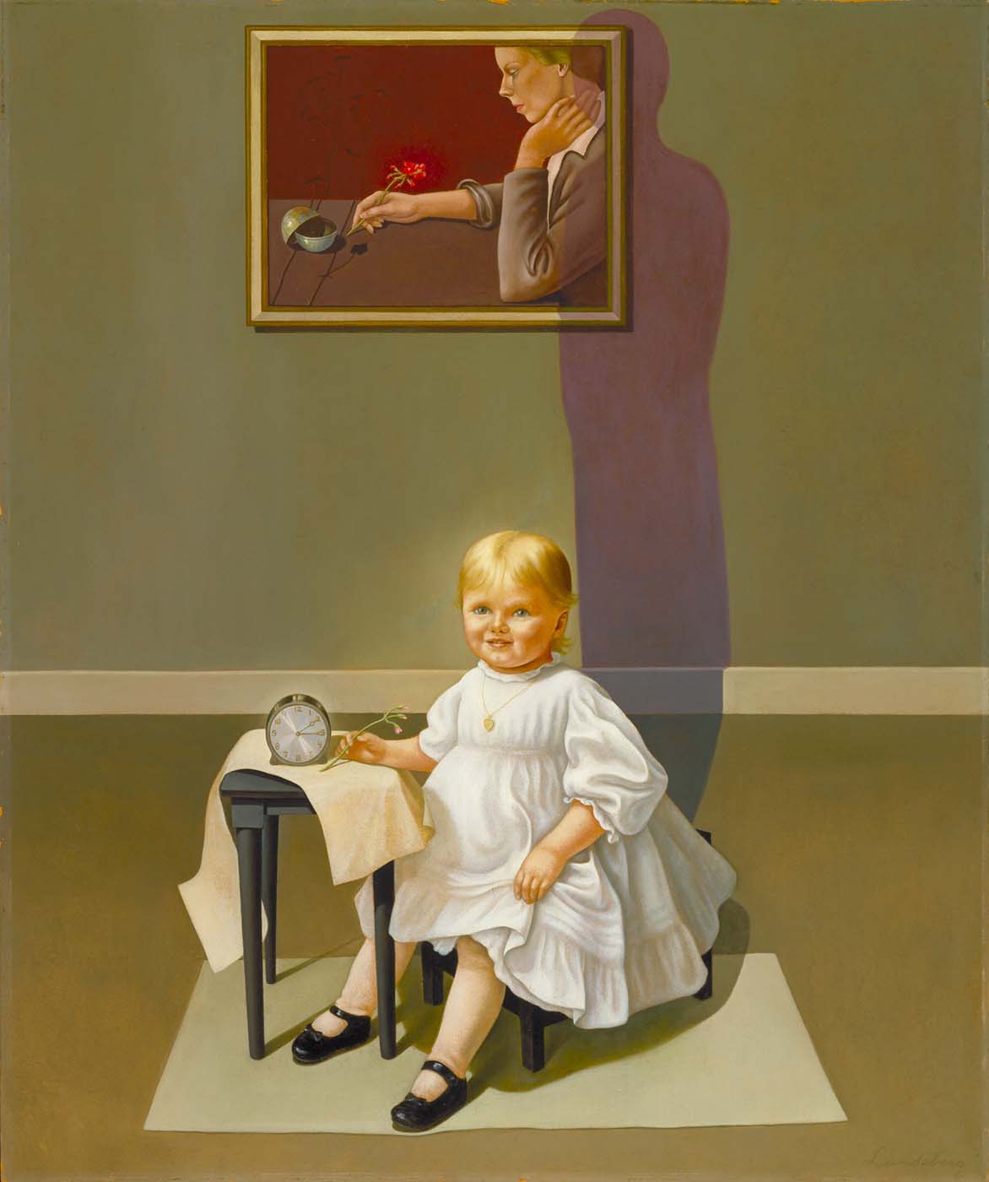
Photo #1

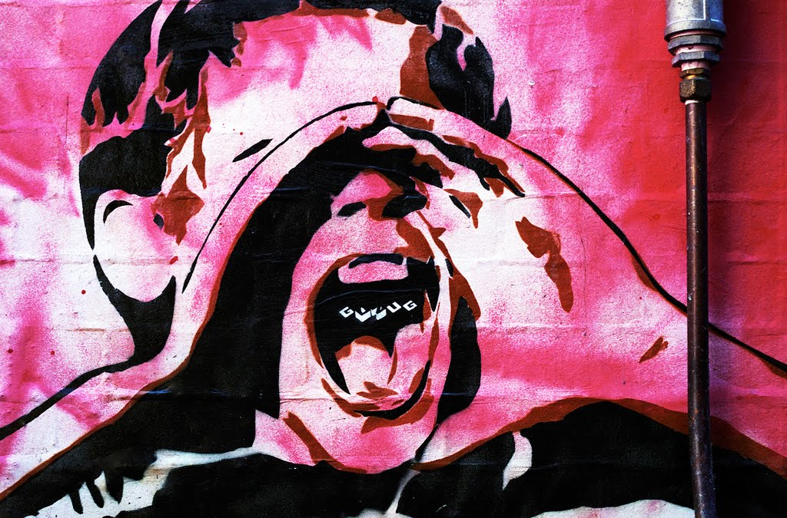
Photo #2

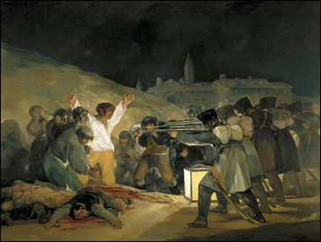
Photo #3

Photo #4
